***Phase 1 ANALYSIS***

**Sub Contents of Analysis Page**

1. **Description of the Problem -**
2. **Objectives -**
3. **Description of existing solution -**
4. **Evaluation of existing solution -**
5. **Description of other possible solutions -**
6. **Description of the Problem**

Background of The System

**Doric Engineering Pvt**. Ltd is a well renowned private company. It is situated in the 91/B, Elephant Road Boro Moghbazar, Dhaka-1217. It sells a profitable number of generators per week. It started as a small private company three years ago. But due to their supply of better quality generators, their number of customers gradually increased.

Currently the company is using a **manual record keeping system** along with two managers, three cashiers and six salesmen only in the sales department. The customer comes to the company’s office and talks with one of the salesmen. The salesman then chooses a set of **generators**, according to the customer’s requirements, and provides them, with full details, to the customer. Then according to the customer’s choice, a generator is chosen and thus, purchased.

The company stays open between Sunday to Thursday from 8 A.M. to 6 P.M. and on Saturday 9 A.M. to 5 P.M. It remains closed on Fridays.

But as the number of customers rapidly increased over the years, I began to suspect a problem that Doric Engineering might start to face- the **drawbacks of the manual record keeping system.**

My Involvement with the Problem

My father is the Chairman of the Doric Engineering Pvt. Ltd. When I visited his office, I was expecting to observe how their recent transactions were taking place and what I saw was something that might be harmful for the company's growth. The ratio of the number of customer to the number of salesman was 5 to 1. The salesman delayed to give proper attention to each customer. Plus, for each customer he had to personally check the **stock** **register** of the system over and over, as it was a manual record keeping. The customer had to wait to make the transactions and when they reached the cashiers, the drawbacks of the manual system started to show again as the bill was made manually, thus slowly. To top it off, the managers were too busy editing the **stock register**. The number of customer was overwhelming and their face expressions gave a feedback of the **manual record keeping system** being was less than satisfactory.

When I inquired about these problems to my father, he seemed to be agreeing with me of searching for a proper solution. I took my chance and asked if I could solve their problem by introducing a computerized database system. Fortunately the Managing Director was present was the decision was made of introducing the computerized database system.

Fact Finding: Method 1 - Interview (Fig: 1.1)

I decided to host an interview with the two managers of the sales department to have a further grasp of the problem being faced and the reasons behind them.

**Interview with the two managers**

1. The method of transaction being used right now, were you aware of its drawbacks?

Ans: Yes, unfortunately we were fully aware of its drawbacks.

1. Have you tried to introduce any sort of alternative method to the transaction system?

Ans: Yes, we have already tried to change some aspects of the method of transaction but it did not seem to help solve the main problems.

1. the owners of the company have decided to solve the current problems by using a computerized database, are you happy about their decision?

Ans: Yes, of course. I am completely agreeing on their decision of using a computerized database system as it may be one of the only efficient solutions to our problems.

1. Are the staff trained enough to handle a computerized database system?

Ans: No, eighty percent of the sales department staff is not trained to use a computerized database system.

1. Do you think a security system is required for the new software that is about to be used in the company?

Ans: Yes, I absolutely think a security system is required to access the database so that data integrity is maintained.

1. Do you have any suggestions or personal choices in the matter of the design of the new software?

Ans: No, I do not have any specific suggestions in the matter of the design of the software, but I only want the software to be user friendly.

My opinion after the interview: The transaction, stock and searching system requires an implementation of a computerized database that would allow easier data manipulation, storage and searching within a short time.

Fact Finding: Method 2 – Observation of the Existing Solution

I observed how the transaction is managed by the staff. And also how the stock and customer registers are managed. And also studied how the invoices and reports are prepared. According to my observation the staffs were facing various obstacles in managing the stock registers as well as the transactions. The manual system seems to have hindered the work efficiency of the company staff. Thus, a new solution was required.

Problem Identification

Later on, some specific customers and staff member, present at that time, were chosen for a short interview and just as predicted the main drawbacks of the manual database system came to light.

* **Maintaining the data keeping is very problematic**

As the system is manual, records are kept in the register by writing which can become lengthy and time consuming. If photocopies are kept every day, for each transaction, then a good amount of cost would be required.

* **Data Integrity is not ensured**

As the database is manual, anyone can get access to them as thus data integrity is lost.

* **Frequent update problem**

The records need to be updated frequently for every purchase of generators. It becomes a very hard task for the staffs to update the records so frequently.

* **Unclear handwriting**

The handwriting of the staff can sometimes be unclear which can lead to dangerous misunderstandings.

* **Transposition and transcription error**

These are errors that are likely to occur while creating or copying records. For instance, someone can read 96 as 69 and accidentally write this number instead.

* **Errors while calculating**

In rush hours calculation mistake may occur as it is done manually using calculators. The cashier can accidentally type 6 as 5 or may be * as +.

* **Finding records**

If the record of a specific product is required, then it becomes extremely difficult to find that record in the database.

* **Field Omission**

The staff can accidentally skip one or more than one of the fields unintentionally.

All of these problems will be solved in the introduction of the new system due to the use of validation and verification. It will be computerized thus handwriting problems, calculation problems, field omission problems and transposition and transcription errors, etc. can be avoided. Finding records will become easier. The database will become easy to update and data integrity will be maintained.

1. **Objectives**

Computerized Objectives

1. **User interface**: The interface of the computerized system should be user friendly so that it is easier to use, by using navigation tools, drop-down lists, etc.
2. **Data storage**: Huge Data should be stored in an orderly manner in separate tables for transaction, customer, etc.
3. **Avoid data duplication and redundancy**: Data will not be duplicated and data redundancy must be avoided by the use of product key, relationship between primary key & foreign key, as a result consistency of data will be increased, like Customer ID used in Transaction table.
4. **Auto ID Generation**: To make the records in the table unique, like Transaction ID, Customer ID.
5. **Validation:** There should be validation and verification checks to reduce the errors in data.
6. **Search & Reports**: The new system should provide faster data searching and faster data reports with much less human intervention.
7. **Security**: There should be a security system to prevent unauthorized people from viewing confidential data.

Business Objectives

1. **Reduces paper cost**: The new system should reduce the extreme paper cost to a minimum.
2. **Reduces** **number** **of** **employees**: The number of employees required for this system is less.
3. **Calculations**: The calculations should be more accurate to prevent the miscalculation of money.
4. **Implementation**: The implementation should be chosen very carefully because if it hampers the transactions then the business can face problems.
5. **Maintenance**: Maintenance should be less time consuming and it should not hamper the process for transactions.
6. **Increase** **efficiency** **of** **staff**: Staff should be able to operate efficiently while in sync with the computerized system.
7. **Increase** **goodwill**: Customer satisfaction increase is also necessary.
8. **Description of existing solution**

Full description of the current system

Doric Engineering Pvt. Ltd is currently using a manual database system. There are two managers, three cashiers and six salesmen only in the sales department. The customer comes to the company’s office and talks with one of the salesmen. The salesman then chooses a set of generators, according to the customer’s requirements and provides them, with full details, to the customer. Then according to the customer’s choice, a generator is chosen and thus, purchased and **provide customer form (Fig: 1.1)**

This is the outside view and it seems pretty easy for the staff. But inside, the company is falling into a jeopardizing situation. The records of transactions, customers and generators are all hand written and stored in manual **registers.** Editing any errors or adding any extra information becomes very difficult. The staff also does jobs of record maintenance, updating, sorting, deleting, making calculations, etc. But there is also the job of searching which is the most fearful one. Because, searching and finding data during transaction, in a company such as this, becomes next to impossible when the data registers are not completely updated or wrongly updated due to human errors. And while editing, all the previous information including the new information is added again to a new page which also consumes a lot of time.

At the end of each day one managers checks the amount of transaction, the number of targets met, etc. And the other manager checks the stock of generators to see if stock re-order is needed. Before leaving, the two managers conduct a meeting with the owner about the transactions, stock, new products, etc.

Process of data input of the Transaction Register (Fig: 1.1)

|  |  |  |  |  |
| --- | --- | --- | --- | --- |
| Sales No. | Date | Generator No. | Name | Address |
| 539 | 18/09/2011 | 103 | Develpoment-2000 Ltd. | Pallabi Extension Dhaka 1216 |
| 540 | 18/09/2011 | 115 | City Lifts Pvt. Limited | Fakirapul, Dhaka |
| 541 | 19/09/2011 | 129 | Square Hospital | Dhanmondi-27, Dhaka |

Process of data input of the Customer Register (Fig: 1.2)

|  |  |  |  |  |
| --- | --- | --- | --- | --- |
| Name | Address | Contact Number | Bank Name | Bank Account No. |
| Develpoment-2000 Ltd. | Pallabi Extension Dhaka 1216 | 01813351868 | EXIM |  |
| City Lifts Pvt. Limited | Fakirapul, Dhaka | 01714489677 | BRAC |  |
| Square Hospital | Dhanmondi-27, Dhaka | 01846686135 | SOUTH EAST |  |

Process of bill invoice (Fig: 1.3)

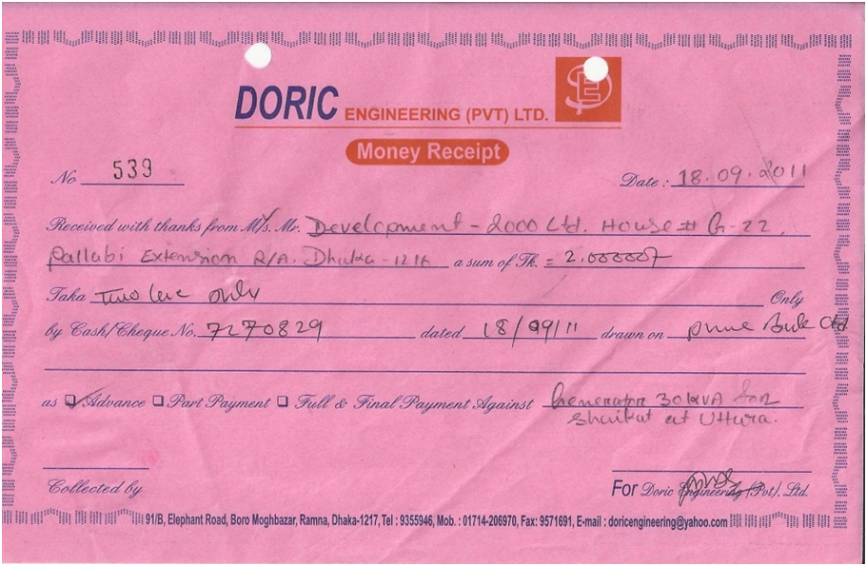

System flowchart of existing system (Fig: 1.4)

A system flowchart of the existing manual record keeping system:

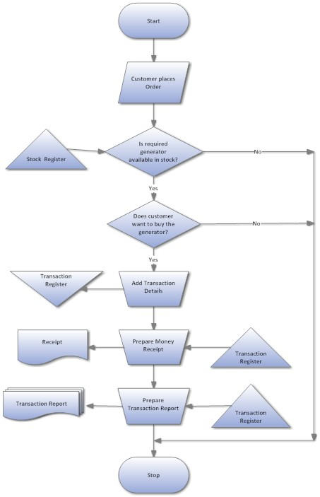

1. **Evaluation of Existing System**

The advantages of the existing system are the following:

* Special training is not required for the staff.
* It is quite efficient when the customer demand is less.
* The structure of the system can be changed very easily.

The disadvantages of the existing system are the following:

* The running and staff cost is very high.
* The speed of customer service reduces along with the increase in the number of customers.
* Data security is almost negligible.
* The data may contain errors as there is no validation system.
* Keeping back up is more costly as it means doubling the amount of materials used for storing data.

Suggested Improvements:

The existing system can be only improved in small-scale because the size of the business does not allow it to increase the fixed factors. The only way to increase possible efficiency is by increasing the variable factors because fixed factors are not variable in short run. The business may decrease the registers and reduce data input requirements, which however may lead to data inadequacy. Data input process can be done by creating a Customer information form where the customer him/herself fills the data. This may save time of asking questions by the staff to the customer but at the same time, the staff has to input the acquired data into the register. Still this may create a change of data validation as the staff can now make corrections.

These possible improvements may slightly change the efficiency in the short run but in the long run permanent solutions are needed. The cost for system operation and running may increase or decrease if improvements are made. Plus, there is no guarantee that the system will become more efficient.

1. **Description of other possible Solutions**

The following are the description of the other possible solutions:

* Increasing the number of staff members: Increasing more staff might be less time consuming and it may solve the problem of delayed service and update but it increases the cost spent on the staff.
* Enlarging the size of the business: Enlarging the size of the business is very much time consuming and it depends on the how well the business is proceeding. Thus, it is not a reliable solution to the problem.
* Data collection using the customer, staff and a computerized system: This method of implementation is the most costly and most time consuming as new forms are needed to be introduced and the customer has to fill up a form as well which is time consuming.
* A completely computerized transaction, customer and stock recording system: Although it takes more time and is a bit more costly, it allows the data to become flawless through validation. It reduces the number of staff needed and updating it is much faster.

Justification of the choice of the proposed system

The existing system can be improved in many ways but, for the betterment of the business the computerized system, though has some starting costs, is able to fulfill the objectives that a company requires in its long run. As it will use electronic databases to store data, the data will be more validated. Data search and report will become easier. The other proposed solutions may improve the system in the short run but will not be able to improve for a run in the long terms. They will cost more and at the end of the day, will be less efficient than the computerized system. The other proposed systems, but the computerized one, will face problems in storing and manipulating and above all searching for data. So, the computerized system is decided to be the solution for the company’s database system. 